turn that down!

The Creation of a Synthesizer

Table of Contents

1 Introduction 3

2 Theory 4

2.1 Terminology 4

2.2 Components 4

2.2.1 Static and variable resistors 4

2.2.2 Capacitors 5

2.2.3 Inverting Schmitt trigger 5

2.2.4 NAND logic gate 6

2.2.5 Operational amplifier and buffer 6

2.3 Building blocks 8

2.3.1 VCO 8

2.3.2 VCF 8

2.3.3 VCA 9

2.3.4 LFO 9

2.3.5 Additional 9

2.3.6 Modulator 9

2.3.7 Sequencer 9

2.4 Typical synth architecture 9

3 Process documentation 11

3.1 Tools 11

3.2 Prototyping 11

3.3 Building the case and assembly 13

4 Conclusion 14

4.1 Critical analysis 14

4.2 Improvements 14

5 Thanks 14

6 Appendix 15

6.1 Additional Images 15

6.2 References 15

# Introduction

I was inspired to write the following paper on the topic of analogue synthesizers[1] due to my fascination for technology and music. While searching for a topic I knew that I needed something which would make me engage and put my energy into. Seeking a challenge, building a Synthesizer seemed to be just right – combining my interests and allowing to discover a domain of technology I hadn’t been familiar with before. It would allow me to learn a lot about analogue electronics, as well as how synthesizers work. In this paper I will first explain what the main components of a synth are, as well as the hidden processes behind the creation of the sound. Then, I will explain how I planned and built a synthesizer myself. My goal is to deeply understand the inner workings of synthesizers while building my own. In my opinion, it is important that we understand the fundamentals of analogue electronics, as these topics go lost with the digitalisation of our world. To achieve this, I will first teach myself the electronic workings of a synthesizer, then build prototypes until I reach a desired outcome. As soon as I hold a working prototype in my hands, the next step will be soldering it onto a soldering board, making it compact. The last step will be putting the raw synthesizer in a nice case. My goal, as well as my dream, is to hold a synthesizer in my hands that I have built and designed myself.

# Theory

To explain how a synthesizer functions, it is important to understand what individual components it consists of and how these components work together. I will use a water analogy to describe the influence of individual parts, as on a high level electrical current functions much like the flow of water. Further, I will use 12V while explaining certain mechanisms, but in every example the voltage could also be smaller or higher.

## Terminology

* Power supply: This is the source of the electricity flowing through the circuit. A battery or a wall socket are power supplies.
* Ground: Name for the point where electricity flows out. In a circuit with a battery as the power supply the negative terminal is the ground [1].
* Voltage: For simplicity’s sake, voltage can be imagined as the amount of pressure in a water pipe. It gives us an understanding of how hard the electrons are being pushed through a circuit. Less voltage means also less water at a time being pushed through the pipe.

## Components

### Static and variable resistors

Now that the terminology is clear, let’s start with the water analogy: Imagine water flowing through a pipe (own drawing 1). In electronics, the wire is the pipe. When the water has no obstacle, it flows freely. Once a resistance, in the case of (own drawing 2) a narrowing of the pipe, is introduced, the amount of the water flowing through the pipe is decreased.

In synthesizers, the voltage is usually constant, for example 12V. This is the amount of pressure of the water going through a pipe. Therefore, a change in resistance changes the flow of the current, which in turn influences the pitch of the tone, as we will later discover.

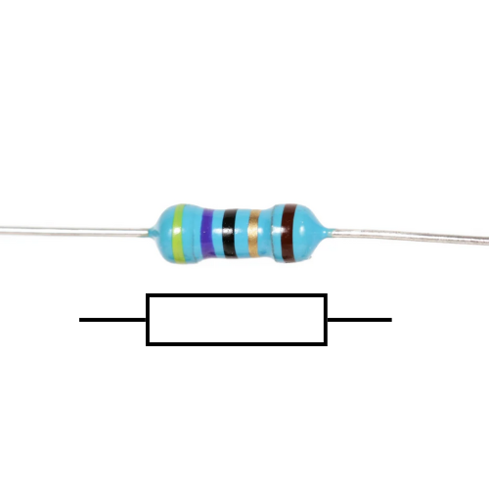

Figure ‑: A five band resistor and its circuit diagram symbol. randofo, Instructables: <https://www.instructables.com/Resistors/> [accessed and edited by Nikolaj Veljkovic 29 09 2024]

Figure 2‑1 shows a static resistor and its symbol. It usually has four to five coloured bands, which allow to identify the resistance of an individual resistor. These colour-codes can be read by using a resistor colour chart [Appendix 6‑1]. As opposed to other components, a resistor is apolar. This means it has no “right” direction. Inside the resistor is a material that inhibits conductivity [2]. This material prevents the full current from passing through the resistor, decreasing the current in the circuit. It is the narrowing of the pipe.

A variable resistor has a different layout. It has three pins, a coil of resistive material and knob attached to a wiper, which is connected to the middle pin . By connecting an input voltage wire to an outer pin, and an output wire to the middle one, this will act as if a static resistor was between the two wires. Only that this resistance can be dynamically changed by turning the knob. As you can see in Figure 2‑3, the longer the connection of the input pin to the wiper head is, the more resistive coil is between the two, the greater the resistance. In a perfect potentiometer, the common name for variable resistor, the knob turned to the maximum corresponds to the maximal resistance. Vice versa, the knob to the minimum should yield no resistance. The maximal resistance is written on the top of the pot(entiometer).

A resistance is measured in Ohm Ω. When the values become big, they are written as kΩ (kiloohm – one thousand ohms) or even MΩ (megaohm – one million ohms).

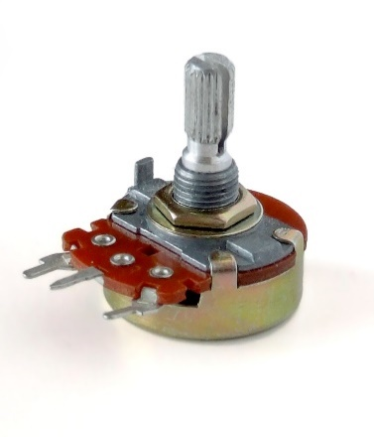

Figure ‑: A potentiometer. Iainf, Wikipedia Commons: <https://commons.wikimedia.org/wiki/File:Potentiometer.jpg> [accessed 29 09 2024]

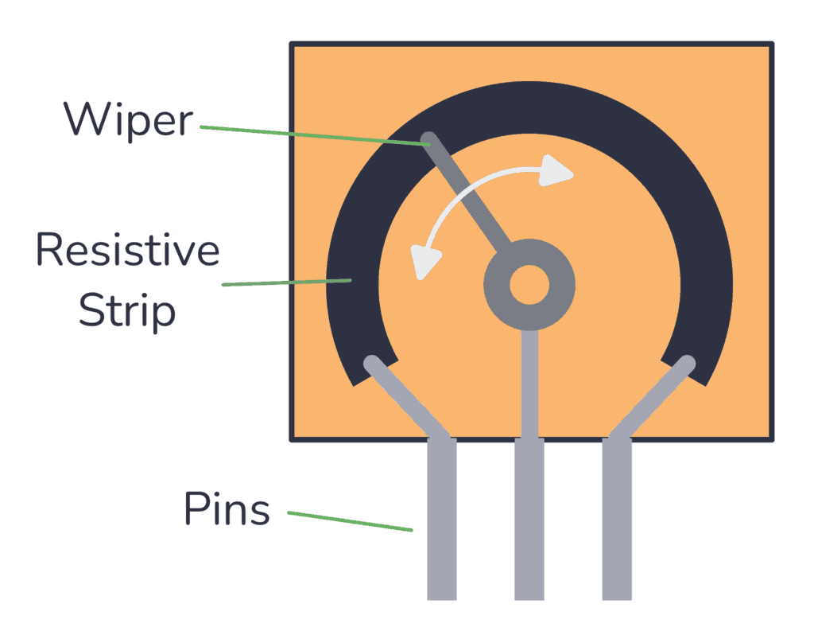

Figure ‑: The inside of a variable resistor. Øyvind Nydal Dahl, buildelectroniccircuits: <https://www.build-electronic-circuits.com/potentiometer/> [accessed 29 09 2024]

### Capacitors

The capacitor in its function is similar to a water balloon (drawing balloon and pipe). When you place the water balloon at the end of a pipe, it fills up with water and stores it. At some point, when the balloon is full, it stops the water from flowing and starts pushing the water back into the pipe. The balloon is discharging [3, pp. 7:35 - 8:57].

In an electronic circuit, the capacitor stores charge on one of two plates. As the electrons build up on one plate, the other plate has less electrons, because it discharged its electrons into the power supply. This creates a potential difference between the two plates, equal to the voltage of the power supply [4]. The more charge it stores, the more the resistance through the capacitor increases. This in turn prevents the current from flowing through the capacitor, effectively stopping the flow in the circuit. However, once the pressure of the current going into the capacitor drops below the capacitor’s own pressure level, the capacitor discharges.

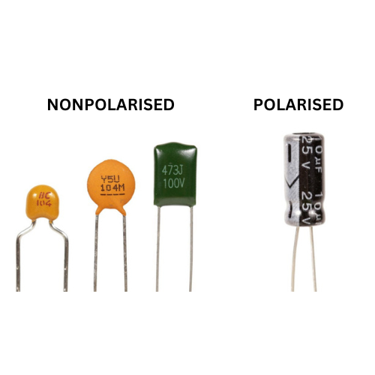

Figure ‑: Different capacitors. unknown, Jak Electronics: <https://www.jakelectronics.com/blog/what-is-non-polarized-capacitor> [accessed and edited by Nikolaj Veljkovic 29 09 2024]

Figure 2‑4 shows multiple capacitors. A capacitors charging capacity, or capacitance, is measured in Farads [5]. In practice, this unit is much too big. Usually capacitors range from Microfarad (mF = 10-6 F) to Picofarad (mF = 10-12 F). In Figure 2‑4 you can see the capacitance denoted very clearly on the polarized capacitor (10mF). On the smaller, nonpolarized ones, it is harder to understand what their capacitance is exactly[2].

### Inverting Schmitt trigger

The following parts are not singular parts, but a combination of different components. They are called integrated circuits (IC) [6]. It is not in the scope of this matura paper to explain how integrated circuits work on a deeper level, as their function is much more important. Also, the following ICs only detect the voltage at the input and process that information. The current does not go directly through the circuit. There is an input for a supply voltage and ground connection. This is where the IC draws energy from, enabling it to output according to the calculated output signal.

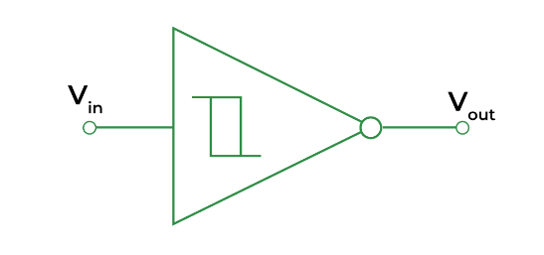A Schmitt trigger is a comparator. This means, it reads the analogue value at its input at compares it to its internal threshold. The exact threshold differs from IC to IC, but it’s easiest to imagine it as right in the middle between maximal and minimal value[3]. If the value at the input is below this threshold, the output reads low. Has the input value surpassed the threshold, the output reads high. This is called hysteresis [7].

Figure ‑: Inverting Schmitt trigger. unknown, GeeksForGeeks: <https://www.geeksforgeeks.org/schmitt-trigger/> [accessed 29 09 2024]

At the same time, the Schmitt trigger is also an analogue to digital converter. A digital signal is defined to be 1 or 0 (equivalent to high or low, on or off), whereas an analogue signal uses a continuous range of values [8]. The signal at the input is analogue, ranging from 0V to 12V, the output is digital, 12V or 0V.

The inverting Schmitt trigger does the same a Schmitt trigger does, only that it outputs the inverse of what a Schmitt trigger would. When the input is over the threshold and the Schmitt trigger would output high, the inverting Schmitt trigger outputs low. And the other way around.

### NAND logic gate

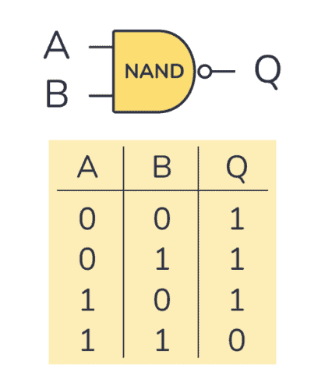

Figure ‑: NAND gate and its truth table. Øyvind Nydal Dahl, buildelectroniccircuits: <https://www.build-electronic-circuits.com/nand-gate/> [accessed [29 09 2024]

This logic gate by itself is not an integrated circuit. In my use case however, it was. NAND is short for NOT AND. In an AND gate, the output is high when inputs one and two are high. The NOT signifies the inversion of that logic. In the logic table (figure something) you can see what this means: The NAND gate always outputs high, except if both inputs are high. This gate also has a threshold to determine if the input is high or low.

### Operational amplifier and buffer

An op-amp, as it’s usually called, has two inputs. The first is called “inverting input”, marked with a minus, the second is the “non-inverting input”, marked with a plus [9]. It also has two power connections, the positive and negative voltage connections.

The op-amp amplifies the difference of its two inputs. For example: It takes the voltage at the non-inverting input, e.g. 8V, and subtracts it by the voltage on the inverting input, e.g. 3V. The result gets amplified by a specific amplification factor called A, e.g. 100’000. The output will therefore be . As this is impossible, the op-amp outputs the maximum supply voltage, 12V.

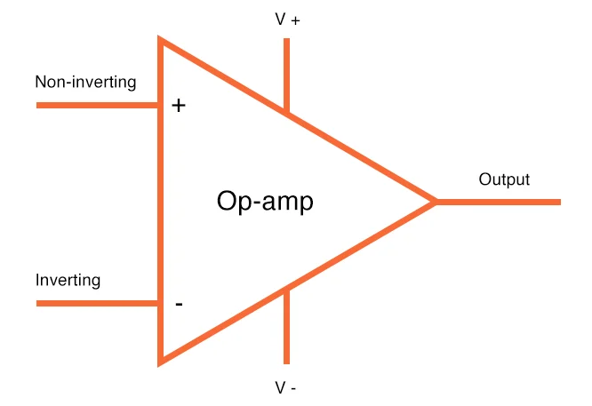

Figure ‑: op-amp. unknown, All About Circuits: <https://www.allaboutcircuits.com/uploads/articles/op-amp-in-schematics.jpg> [accessed 29 09 2024]

The op-amp having its own power source brings great advantages with it, as it allows the output current to be very stable. An oscillator signal is often wavering[4] around instead of being stable, due to different parts acting unpredictably. Stabilisation of the signal is one of the main issues of sound technologies, which makes buffers a very important utility.

In a buffer (figure something), there is a signal coming into the non-inverting input, for example 9V. The inverting input is connected to the buffers output. In the beginning, the output is zero, therefore, the inverting input is also zero. The subtraction equals 9V, so the op-amp will try to output 9V. As it does so, after a fraction of a second the output will be at e.g. 3V. This makes the difference smaller, but the gain with which it gets amplified is still large enough that the output rises. This will keep happening until the difference of the two inputs is extremely small. The output will then be approximately the same value as the non-inverting input. This is called a negative feedback loop [10]. Buffers are used in most audio processing technologies, because they reduce the unsteadiness of a signal.

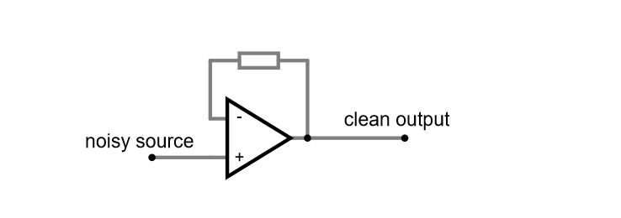

Figure ‑: An op-amp buffer. Nikolaj Veljkovic, Falstad: <https://tinyurl.com/23cypsgv> [created 29 09 2024]

## Building blocks

### VCO

The “Voltage Controlled Oscillator” is the sound source of the instrument. The sound’s characteristics are defined by its wave. Depending on how many waves there are per second, the pitch either goes up or down. The shape of the wave makes the sound either smooth or noisy, loud or quiet, and anything in between.

The most common waveshapes are: Square, Triangle, Sine, and Sawtooth, as seen (figure with the waves). Different waveshapes produce different sounds. From left to right the sound gets more harsh. While a sine wave could be compared to the sound produced by a flute, the square wave has a typical synth grit and harshness.

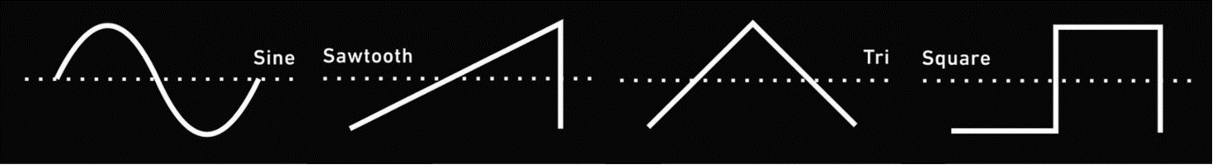

Figure ‑: A comparison of four wave shapes. On the x-axis: time. On the y-axis: voltage. Length of the waveshape: one cycle. unknown, Pinterest, <https://www.pinterest.com/pin/1009087860241726171/> [accessed and edited by Nikolaj Veljkovic 18 08 2024]

An oscillator can be demonstrated with the circuit in figure 2‑10. The two main components are the capacitor and the inverting Schmitt trigger. The oscillation starts, with the capacitor assumingly discharged (around 0V). This leads the inverted Schmitt trigger to output high, charging the capacitor through the resistor. Once the capacitor is charged, the Schmitt trigger switches to low, because the voltage at its input is high. Now, the capacitor starts discharging through the resistor, and once it’s discharged, one cycle of the oscillation is complete [11]. This is a very basic square wave oscillator. With the potentiometer it is possible to control how much of the current passes into the capacitor. The higher the resistance, the less current can flow, the slower the cap charges, the slower the oscillation, the lower the pitch. Resistance is therefore directly connected to the pitch and is used to control it.

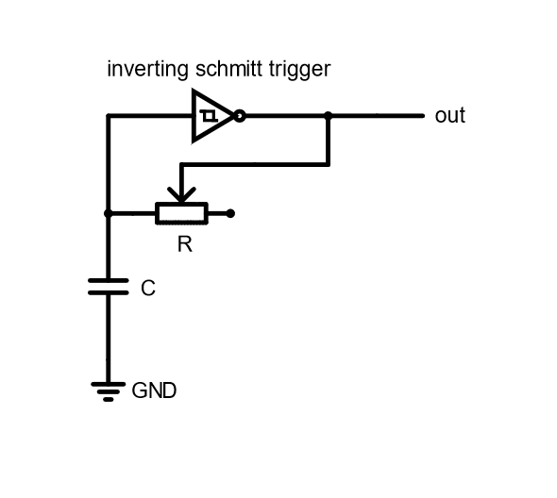

Figure ‑: A simple square wave oscillator. Nikolaj Veljkovic, falstad.com: <https://tinyurl.com/29x8r54f> [created 18 08 2024]

### VCF

When we hear a tone, it is never just a pure tone. When the string of a guitar swings, there are tones ringing over the base tone. The overtones, as they are called, are certain intervals away from the base tone [12]. This effect is very common in nature, even our voices have overtones. When looking at a frequency spectrum [Figure 2‑11] of the middle g on the piano, multiple spikes are visible after that of the base tone. These spikes visualise the overtones.

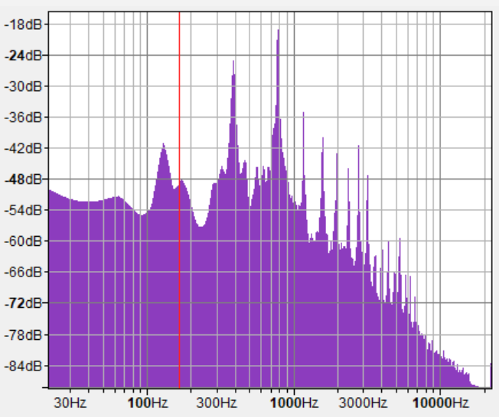As I mentioned in sub-chapter 2.3.1, depending on how many times a wave occurs in a second, the pitch changes. The amount of waves per time is called frequency. Thus, the spikes in frequency are further pitches, or waves, swinging with the main wave, just at a faster rate.

Figure ‑: A frequency analysis of the g note played on a piano. Nikolaj Veljkovic, Audacity [created 27 09 2024]

A “Voltage Controlled Filter” can cut off certain frequencies from the sound. Imagine a filter in a water pipe, sorting out all the dirt. The VCF can be configured in two ways: a low pass filter, and a high pass filter. As their name implies, the former cuts off all the high frequencies, where the latter cuts out all the low ones. A low pass filter (figure low pass) consists of a resistor and a capacitor. If we recall our water analogy, the oscillation and the overtones can be seen as a sputtering of water through the pipe. The resistor controls how much water (current) can pass the pipe at once. Instead of letting the sputter continue to the output, the capacitor acts as a bucket into which the water can dribble into. Once the backet is full the water can continue in a normal flow further to the output.

Those fast waves, our overtones, have thus been filtered out. By using a potentiometer we can control how much water can pass through to the bucket. The less water passes, the slower the bucket fills up, the more high frequencies are filtered out. Drain capacitor is the name for such a capacitor, as it drains the high frequencies into ground. If you would like to see how the wave shapes compare to each other, see (appendix something).

### VCA

After a VCO and VCF, a synthesizer produces sound, whose pitch can be controlled. What cannot be controlled is the dynamics of that sound. The expression of the sound, alike to a violin player when they play a note quietly at first and get louder towards the end. It is not possible to play a note like pressing a piano, there is no control over the pauses in the sound.

The “Voltage Controlled Amplifier” gives the possibility of dynamics to the synthesizer. It reacts to the control voltage, CV for short. The CV can be a further oscillator, like a sine wave, or just a press of a button, resulting in a chain reaction. The VCA could try to imitate a piano, or grow louder and quieter, following the sine wave.

The shape of the sound can be described in accordance to the following characteristics: Attack, decay, sustain and release, also called ADSR. The ADSR envelope is a common way to describe how sound behaves over time [13]. The attack is how quickly after the beginning of the sound it reaches its peak. Decay determines how quickly it goes from the peak to a steady level. The steady level is you still holding the key, sustaining the sound. The loudness of that steady level is called sustain. Finally, the release tells us how quickly the sound goes quiet after the key has been released. In (figure ADSR) a single note played on a violin and on a piano are compared.

### LFO

At its core, the “Low Frequency Oscillator” is nothing else than a slow VCO. While the VCO oscillates in ranges which we perceive as pitches, the LFO produces sounds which to us sound more like clicks.

LFOs are used to manipulate the modules mentioned in the previous sub-chapters. This process is called modulation. For example, a LFO could be hooked up to a VCF, whose cut off point depends on the control voltage, provided by the LFO. When the CV input of the VCF is low, then almost the whole signal passes. When it’s in a higher range, more of the frequencies get cut off. You might be familiar with the “wah-wah” effect on guitars. This is nothing else than a modulation of the sound, only that guitarists do it with their own foot instead of a LFO [14].

### Additional

### Modulator

### Sequencer

## Typical synth architecture

Every synthesizer is different, yet many possess commonalities. The architecture of a synthesizer describes what modules (which we previously called building blocks) it is made of and in what order they are chained to each other. Usually, the first is the VCO. This makes sense: First the sound has to exist before it can have something done to it. After, the VCF follows. It cuts off or adds certain frequencies, before the sound continues to the VCA, where expression comes in. The LFO could be attached to any of the modules and modulate them individually. For example, it could change the amount of cut off over time. Or, it could influence the pitch [15].

# Process documentation

## Tools

After I had some idea of what a synthesizer does, it was time to start prototyping. Thanks to Sacha Di Piazza, who is my mentor and supervisor, I didn’t have to buy any materials. He gave me all the parts I needed, as well as tools and a power supply. In figure [n] you can see the tools I used while prototyping. The red box (1) is a digital oscilloscope. It displays the time on the x-axis and voltage level on the y-axis. The waveshapes in figure 1 are displayed using the same method. It was incredibly useful in helping me understand how the oscillator behaves when I tweak or exchange certain components. On the wooden board is the prototype of the synthesizer, stuck into a breadboard. The metal frame (3) is used for combining different modules. I only used it as a power supply, as Sacha built a special supply into it that could be directly stuck onto the breadboard. The soldering iron (4) is what I used when soldering the board together. Number 5 are pliers, which were extremely helpful when I had to cut wires or pull off the isolation from the wire. In the upper left part of the picture you can see a lamp. I transformed my microphone boom arm into a highly adjustable desk lamp. This was very useful when working in the dark or having to see something very tiny.

## A circuit board with wires and wires Description automatically generatedPrototyping

Before I started building my synthesizer, I first had to know what a synthesizer is at its core. I had an idea of what synthesizers do, but I didn’t have a clue how they did it. First, I read “Elektronik Basteln für Dummies” [16], which helped me understand some core elements of electronics. For the synthesizer logic, I read “Handmade Electronic Music” [17]. This phenomenal book opened my eyes to how simple some processes in the synthesizer actually are, and really motivated me to build one myself.

The most basic oscillator is a square wave oscillator. Following a guide in “Handmade Electronic Music” [17, p. 116], it was surprisingly simple to build: The only parts required were a 10nF capacitor, a 100kΩ resistor and a HEF40106BP, which has six inverting Schmitt triggers. The joy I felt at the screaming sound out of my first VCO was incredible. You can see how this simple oscillator is configured in Figure 3‑1.

Figure ‑ A simple square wave VCO

The problem with this design is that it’s not very user friendly. It produces the same sound in the same pitch all the time. To change this, I substituted the normal resistor with a 100kΩ potentiometer. It can go from 100kΩ to 0Ω resistance. Because of this I had to add a small pre-resistor of 1.2kΩ, to prevent frying the circuit when the potentiometer let all the current pass. With a dynamically changeable resistance I could change the pitch of the sound as I wished. By changing around the value of the capacitor and resistor, I could choose the range I wanted my sound to be in. The low range pleased me a lot, so I chose a big resistor. But I still wanted to be able to have some squeaky sounds, so I had to have a small capacitor which could charge quickly. I chose a 100kΩ potentiometer and a 220mF capacitor.

Being satisfied with the result of one VCO, I added one more. And then, one more. Next, I started experimenting around with filters. In Figure 3‑2 you can see three similar VCOs. The two upper ones pass through a resistor before going into the jack output. I did this to see if it would change the stability of the sound in any way. It lowered the volume of those channels and removed some of the noise. The third VCO passes through a low-pass filter before going through the volume reducing resistor and then into the output.

Figure ‑ Three VCOs, one of them has a filter

The low pass filter works as described in [insert theory chapter here]. It has a 10nF drain capacitor and a 100kΩ resistor. This gave me a good idea of how far down I want to cut down the frequencies. It allowed me to play around with different sounds, but it wasn’t very dynamic. Therefore, I substituted the static resistor with a variable one, which now enabled me to cut off the high frequencies as I wished.

Next, I wanted to test a different IC, because I got inspired by a design [17, p. 132] in “Handmade Electronic Music”. The IC I used for it is the CD4011. It consists of four NAND gates. I coupled two NAND gates together by taking the output of the first and connecting it to the input of the second. The input of the first NAND gate is a capacitor to ground and a 12V supply. One input of the second NAND gate is the first NAND’s output. The second input is a capacitor connected to ground. As the capacitor oscillates by itself and the first input oscillates by itself, this leads to interesting combinations of waves. I did the same with the remaining two gates in the IC. This way, I had two VCOs, each consisting of two coupled NAND gate oscillators.

At first, I only put a potentiometer in the first oscillator of the VCO. My expectation when combining the two sources was to hear two separate oscillators, like a violin and flute playing together. Instead, it was one mixed sound. Turning one knob influenced the sound as a whole, even though the VCOs were only connected at the output. To go even further, I replaced the static resistors in the second oscillator of the VCO again with potentiometers. I had the feeling that one VCO manipulated the other now even more. To test this, I attached the oscilloscope and what I found astounded me: They were influencing each other! When both VCOs were slow, the square wave was very wide. However, if one VCO was slow and the other fast, the fast one played only when the square wave of the first one was high. This phenomenon probably has to do with my circuit not being perfect. Somewhere the electricity might have been leaking into the other VCO, which made them influence each other. I didn’t mind this at all, though. I even liked the sound and, to some extent, the unpredictability of it. It also made the picture on the oscilloscope very captivating to look at.

* Simple Circuit to check if it works, testing
* Day 1: Research, Moritz Klein, understanding the book/processes
* First design: Four VCOs, one modulation, VCF, Schmitt Triggers
* Second design, two NAND double VCOs, NAND logic, active filter, buffering
* Maybe sequencer?

## Building the case and assembly

For the case, I knew from the beginning that it should be in a box. I liked the idea of having a somewhat “rustical” synthesizer, on which I could put my own hand writing. For a long time, however, I couldn’t find anything which pleased my imagination exactly. Therefore, I chose an old perfume box my mother had lying around.

In (figure 1) is the rough drawing of the layout I wanted. Before, I planned it in my notebook (maybe appendix scan?). I put the potentiometer with the knob on the top of the box and drew a rough circle where it should pass through. The plan was to drill a hole and then stick the knob of the potentiometer through from below. I did the same process for the other four as well. Then, I drilled the holes on my balcony, as this is the closest I have to a work bench at home (figure drilling). Before putting the potentiometers through the holes, I wanted to colour it first.

The colouring was quite simple, but time consuming. It wasn’t possible to colour onto the box directly, as the print wouldn’t allow for it to be even. Thus, I taped it with yellow tape (figure box). This gives the synthesizer it’s weird, uneven look. Me and my mother, saving time and bonding simultaneously, coloured the case with a dark blue marker.

The potentiometers I used have a nut screw, which can be taken off. They also have a small bit of metal standing out, assumingly used to fix the potentiometer in its position. I couldn’t use that and it made the positioning of the potentiometer quite difficult. So I broke it off (figure pots). After putting the knob of the potentiometer through the hole, I screwed it tight with the nut screw I had taken off before. A mistake I made while drawing the design was, that I didn’t account for the size of the body of the potentiometer. This led to me having to squeeze them together and even put a sheet of isolation tape in between, because the metal was touching.

Up to that point, I had not drilled the holes for the audio output and the power supply. I didn’t know where they would exactly be after I put the potentiometers in the cover of the box. After putting those parts together, I could draw in the position of the two and start drilling. For colouring the body of the box I used the same process. The most difficult of all the process, was getting the audio jack through the hole. It was impossible for me to pull it through the hole without putting the lid on, which in turn meant I couldn’t move the audio jack. I solved it by threading a thin audio cable through the hole and sticking it into the jack input. When the box was closed I had to pull extremely slowly, to not yank the cable out. After several tries, the help of my mother’s thin fingers and cries of frustration, we managed to push it through the hole. I stabilised it with a nut screw, similar to the potentiometers.

For the power supply I wanted to make two thin holes. However, I pushed a little too hard while drilling, which made a bigger hole than required. I decided to put both wires through one hole (figure synth back).

Satisfied with the look of the synthesizer, I decided to test it. I attached the two wires to the 12V power supply, and hooked up a speaker to the audio jack. Immediately after turning on the power, the synth came to life. However, I quickly realised that something was wrong. The VCO knobs didn’t act as they did in the previous test. And instead of the filter cutting of frequencies, it randomly either turned the whole sound of, or modulated the pitch. I was very unhappy, but due to my tight schedule I couldn’t go back and fix the issue.

Luckily, I hadn’t labelled the synthesizer yet. I had been playing around with names for a while, but “turn that down!” was the one that I liked the most. It was what my mother told me, after hearing the sound of it for the first time. Using a white crayon, I wrote the name on the top of the synth. I intentionally wrote it very weirdly, to match the already rugged appearance and the weird sounds. The knob which was once a filter got named “random”, and the VCOs became “pitch”. I also wrote “out” next to output jack and “V in” next to the power supply cables. The latter doesn’t make much sense, it would have been better to simply write “power” or just “V”.

# Conclusion

## Critical analysis

## Improvements

# Thanks

# Appendix

## Additional Images

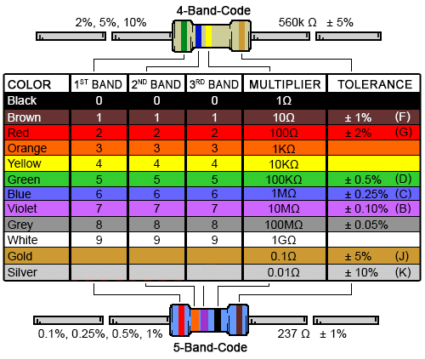

Appendix ‑: A resistor colour chart. unknown, DigiKey: <https://www.digikey.com/-/media/Images/Marketing/Resources/Calculator/resistor-color-chart.png?la=en-US&ts=4db603f5-4e9b-4759-84b7-21a04d18b1a8> [accessed 29 09 2024]

## References

|  |  |
| --- | --- |
| [1] | Ø. N. Dahl, “What is Ground in Electronic Circuits?,” buildelectroniccircuits, 18 09 2020. [Online]. Available: https://www.build-electronic-circuits.com/what-is-ground/. [Accessed 27 09 2024]. |
| [2] | EETech Group, “EEPower,” [Online]. Available: https://eepower.com/resistor-guide/resistor-materials/. [Accessed 24 06 2024]. |
| [3] | M. Klein, “DIY SYNTH VCF Part 1: Analog Filtering Basics,” Moritz Klein on Youtube, 15 12 2020. [Online]. Available: https://www.youtube.com/watch?v=3tMGNI--ofU. [Accessed 03 07 2024]. |
| [4] | University of Birmingham, “Physics A level revision resource: Introduction to capacitors,” University of Birmingham, 2024. [Online]. Available: https://www.birmingham.ac.uk/study/undergraduate/schools-and-colleges/post-16/a-level-stem-resources/capacitors. [Accessed 03 07 2024]. |
| [5] | P. Ravarini, «Farad,» Pravarini, 2024. [En ligne]. Available: http://pravarini.free.fr/Farad.htm. [Accès le 26 09 2024]. |
| [6] | Britannica, “integrated circuit,” Britannica, 24 06 2024. [Online]. Available: https://www.britannica.com/technology/integrated-circuit. [Accessed 26 09 2024]. |
| [7] | Wikipedia, “Schmitt trigger,” Wikipedia, 21 09 2024. [Online]. Available: https://en.wikipedia.org/wiki/Schmitt_trigger. [Accessed 2024 09 25]. |
| [8] | Tutoroot, “What are Analog and Digital Signals?,” Tutoroot, 01 05 2023. [Online]. Available: https://www.tutoroot.com/blog/what-are-analog-and-digital-signals-definition-difference-examples/. [Accessed 25 09 2024]. |
| [9] | Toshiba, “What is an op-amp?,” Toshiba, 2024. [Online]. Available: https://toshiba.semicon-storage.com/ap-en/semiconductor/knowledge/faq/linear_opamp/what-is-an-operational-amplifier.html. [Accessed 26 09 2024]. |
| [10] | M. Klein, “DIY SYNTH VCF Part 2: Active Filters & Resonance,” Moritz Klein on Youtube, 04 01 2021. [Online]. Available: https://www.youtube.com/watch?v=YNoj9Rrw_VM. [Accessed 26 09 2024]. |
| [11] | E. Corpeño, “Exactly How Schmitt Trigger Oscillators Work,” All About Circuits, 23 05 2018. [Online]. Available: https://www.allaboutcircuits.com/technical-articles/exactly-how-schmitt-trigger-oscillators-work/. [Accessed 28 09 2024]. |
| [12] | R. E. Berg, “Overtones,” Britannica, 13 09 2024. [Online]. Available: https://www.britannica.com/science/sound-physics/Overtones#ref-14249. [Accessed 28 09 2024]. |
| [13] | M. Müller and T. Zunner, “Timbre,” AudioLabs Erlangen, 2015. [Online]. Available: https://www.audiolabs-erlangen.de/resources/MIR/FMP/C1/C1S3_Timbre.html. [Accessed 28 09 2024]. |
| [14] | 3D Varius, “History of the wah,” 3D Varius, 22 04 2022. [Online]. Available: https://www.3d-varius.com/history-of-the-wah/. [Accessed 28 09 2024]. |
| [15] | D. Solaris, “Synthesizer basics,” Don Solaris Sound Design, 18 03 2014. [Online]. Available: https://www.donsolaris.com/?p=493. [Accessed 29 09 2024]. |
| [16] | G. Weichhaus, Elektronik Basteln für Dummies, Wiley-Vch, 2020. |
| [17] | N. Collins, Handmade Electronic Music: The Art of Hardware Hacking, 2nd ed., Routledge, 2009. |
| [18] | S. B, “Electronics StackExchange,” 05 04 2021. [Online]. Available: https://electronics.stackexchange.com/a/558607. [Accessed 09 06 2024]. |
| [19] | crashdmj, “Reddit r/FastLED,” 2022. [Online]. Available: https://www.reddit.com/r/FastLED/comments/va6u1p/hardware_question_for_sound_reactive_35mm_jack/. [Accessed 09 06 2024]. |
| [20] | S. J. Battle, “LOOK MUM NO COMPUTER,” 16 10 2017. [Online]. Available: https://www.lookmumnocomputer.com/projects/#/simplest-oscillator. [Accessed 09 06 2024]. |
| [21] | BBC Authors, “BBC Bitesize,” 2024. [Online]. Available: https://www.bbc.co.uk/bitesize/guides/z48gmfr/revision/2. [Accessed 24 06 2024]. |
| [22] | R. L. Taylor, “Electron Current vs. Conventional Current,” 21 09 2017. [Online]. Available: https://web.engr.oregonstate.edu/~traylor/ece112/lectures/elect_flow_vs_conv_I.pdf. [Accessed 24 06 2024]. |
| [23] | R. Wilson, “MFOS Ten Step Analog Sequencer,” Music From Outer Space, 10 06 2010. [Online]. Available: https://musicfromouterspace.com/analogsynth_new/TENSTEPSEQUENCER/TENSTEPSEQUENCER.php. [Accessed 05 07 2024]. |

Figure 2‑1: A five band resistor and its circuit diagram symbol. randofo, Instructables: https://www.instructables.com/Resistors/ [accessed and edited by Nikolaj Veljkovic 29 09 2024] 4

Figure 2‑2: A potentiometer. Iainf, Wikipedia Commons: https://commons.wikimedia.org/wiki/File:Potentiometer.jpg [accessed 29 09 2024] 5

Figure 2‑3: The inside of a variable resistor. Øyvind Nydal Dahl, buildelectroniccircuits: https://www.build-electronic-circuits.com/potentiometer/ [accessed 29 09 2024] 5

Figure 3‑1 A simple square wave VCO 11

Figure 3‑2 Three VCOs, one of them has a filter 12

Appendix 6‑1: A resistor colour chart. unknown, DigiKey: https://www.digikey.com/-/media/Images/Marketing/Resources/Calculator/resistor-color-chart.png?la=en-US&ts=4db603f5-4e9b-4759-84b7-21a04d18b1a8 [accessed 29 09 2024] 15

Figure 6‑2: A comparison of four wave shapes. On the x-axis: time. On the y-axis: voltage. Length of the waveshape: one cycle. unknown, Pinterest, https://www.pinterest.com/pin/1009087860241726171/ , [accessed 18 08 2024], edited by Nikolaj Veljkovic 17

Figure 6‑3: A simple square wave oscillator. Nikolaj Veljkovic, falstad.com, https://tinyurl.com/29x8r54f , [created 18 08 2024] 18

Figure ‑: A comparison of four wave shapes. On the x-axis: time. On the y-axis: voltage. Length of the waveshape: one cycle. unknown, Pinterest, <https://www.pinterest.com/pin/1009087860241726171/> , [accessed 18 08 2024], edited by Nikolaj Veljkovic

1. Throughout this paper I will use the standardised American spelling of the instrument.
2. If you are interested in finding out, go to: <https://www.wikihow.com/Read-a-Capacitor>
3. For the exact explanation, go to: <https://www.ti.com/lit/ab/scea046a/scea046a.pdf?ts=1727485822924>
4. The «wavering» is called noise.